Educational Organisation Using ServiceNow

Team Size : 4

Team Leader : Kanaparthi.Aruna Sri

Team member : Ganapathi G

Team member : Bhavya Tatineni

Team member : Divvela Jagadeesh

1. INTRODUCTION

1.1 Project Overview
Educational institutions manage a wide range of academic and administrative functions on a daily basis. These include processing student requests, coordinating faculty activities, maintaining academic records, and delivering various support services. In many cases, such operations are still handled manually or through multiple disconnected software systems. This fragmented approach often results in delays, miscommunication, duplication of work, and reduced overall efficiency.
The Educational Organisation Using ServiceNow project aims to address these challenges by implementing an integrated and automated management system. ServiceNow is a cloud-based enterprise platform designed to streamline workflows, centralize data management, and enhance operational performance. By leveraging its low-code capabilities, institutions can digitize their processes without developing complex applications from scratch.
This project proposes a centralized digital environment where students, faculty members, and administrative staff can collaborate through a single unified platform. Students are able to submit academic or administrative requests online, faculty members can manage course-related activities and student records, and administrators gain real-time visibility into institutional operations. Such centralization promotes transparency, accountability, and improved communication among stakeholders.
A key feature of the system is workflow automation. Once a request is submitted, the platform automatically routes it to the appropriate department or authority based on predefined rules. Notifications, status updates, and approvals are managed systematically, reducing manual intervention and minimizing errors. This structured flow ensures faster response times and consistent service delivery.
Overall, the implementation of ServiceNow in an educational environment enhances productivity, improves data accuracy, and simplifies institutional management. By replacing manual and fragmented processes with an automated, centralized solution, the project contributes to more efficient academic administration and better service experiences for students and staff.

1.2 Purpose

The primary objective of this project is to design and implement an efficient, automated system for managing educational institution services using the ServiceNow platform. The system is intended to streamline institutional operations by improving communication and coordination among students, faculty members, and administrators. By digitizing service requests and approvals, the platform ensures that tasks are processed quickly, accurately, and transparently.

Another key purpose of this project is to minimize manual work and reduce paperwork within educational organizations. Traditional paper-based and semi-digital systems often lead to delays, misplaced records, and inconsistent tracking. Through workflow automation, the proposed system organizes processes in a structured manner, allowing institutions to manage academic and administrative services more effectively.

The project also focuses on enhancing request tracking and accountability. Every submitted request is recorded within the system, assigned to the appropriate authority, and monitored until completion. This improves transparency, ensures timely task completion, and enables administrators to evaluate performance through systematic monitoring. Overall, the system supports efficient service management while promoting reliability, accountability, and operational excellence.

2. IDEATION PHASE

2.1 Problem Statement

In many educational institutions, managing student services and administrative responsibilities remains a complex and time-consuming task. Students frequently submit requests related to certificates, academic records, course details, or grievance issues. When these processes are handled manually or through disconnected systems, resolution times increase significantly. Moreover, the absence of a structured tracking mechanism makes it difficult for students to monitor the progress of their requests, leading to uncertainty and dissatisfaction.

Faculty members and administrators also encounter challenges when dealing with a high volume of student queries and operational tasks. Without a centralized platform, communication gaps arise, responsibilities become unclear, and important information may be delayed or misplaced. This not only increases staff workload but also affects the overall efficiency and responsiveness of the institution.

To overcome these challenges, there is a clear need for a unified system that centralizes educational services, automates workflows, and streamlines communication between students and administrative departments. The Educational Organisation Using ServiceNow project addresses these issues by introducing an integrated and automated solution. By leveraging ServiceNow’s workflow capabilities, the system ensures structured request handling, real-time status tracking, improved transparency, and faster service delivery. Ultimately, the platform enhances institutional efficiency while improving the overall experience for both students and staff.

2.2 Empathy Map Canvas

Section: Says
- “Handling student records manually takes too much time.”
- “It would be better if paperwork could be reduced.”
- “Preparing and compiling performance reports consumes many hours.”

Section: Thinks
- “There must be a smarter method to manage these repetitive tasks.”
- “Manual data entry may lead to mistakes that impact student records.”
- “Technology could simplify this process, but I am unsure how to begin.”

Section: Does
- Completes admission forms manually.
- Records and updates student marks in notebooks or Excel sheets.
- Tracks admission progress without automated tools.
- Shares student data manually with other departments.

Section: Feels
- Frustrated because of inefficient processes.
- Concerned about possible data inaccuracies.
- Tired of performing repetitive administrative tasks.
- Interested in exploring digital solutions.

Section: Pain Points
- Manual data entry consumes significant time.
- High possibility of human errors.
- Difficulty in tracking admissions and records efficiently.

Section: Gains / Needs
- A centralized digital system to manage and update student information.
- Automatic calculation of results and reports.
- Simple and accurate admission tracking process.
- A clean, user-friendly interface for easy operation.

2.3 Brainstorming
During the brainstorming phase, several ideas were discussed to solve the identified problems. The main goal was to create a system that could simplify educational processes and improve efficiency.
Some of the ideas discussed include:
- Creating a centralized service portal for students and faculty.
- Implementing workflow automation to handle requests automatically.
- Providing real-time notifications to users.
- Using ServiceNow to manage educational services effectively.
- Designing a user-friendly interface for easy access to services.
After evaluating these ideas, the team decided to implement the system using the ServiceNow platform because of its strong workflow automation capabilities and service management features.

3. REQUIREMENT ANALYSIS

3.1 Customer Journey Map

The customer journey describes how users interact with the system from start to finish. The process begins when a user logs into the system and continues until the request is resolved.

The steps involved in the journey include:
- The user logs into the ServiceNow portal.
- The student selects a service and submits a request.
- The system verifies the request details.
- The request is forwarded to the appropriate department.
- The concerned authority reviews the request.
- The request is approved or rejected.
- The system notifies the student about the status of the request.

This journey ensures a smooth and structured process for handling requests within the institution.

3.2 Solution Requirements

Functional Requirements

The functional requirements define the features that the system must provide:
- User registration and login system.
- Student service request submission.
- Workflow-based approval process.
- Notification system for updates.
- Request tracking system.
- Administrative dashboard.

Non-Functional Requirements

The non-functional requirements define the quality attributes of the system:
- Security and data protection.
- High system performance.
- Scalability for future expansion.
- Reliability and availability.
- User-friendly interface.

3.3 Data Flow Diagram (DFD)

The Data Flow Diagram explains how data moves through the system.

Student → System: Submit request
System → Department: Assign request
Department → System: Update status
System → Student: Notify result
Administrator → System: Monitor activities

This process ensures efficient handling of data and requests within the system.

3.4 Technology Stack
The system is developed using the following technologies:
Platform: ServiceNow
Modules Used:
- Service Catalog
- Incident Management
- Workflow Automation
- User Management
Tools Used:
- ServiceNow Studio
- Flow Designer
- Service Portal

4. PROJECT DESIGN

4.1 Problem–Solution Fit

The proposed system directly addresses the problems faced by educational institutions. By implementing a centralized platform, the system eliminates manual processes and improves communication between students and administrators.

The system ensures that requests are handled efficiently, and users can track their status at any time. This improves transparency and accountability within the organization.

4.2 Proposed Solution

The solution involves creating a ServiceNow-based portal where users can access various educational services. Students can submit their requests through the portal, and the system automatically routes these requests to the appropriate departments.

Faculty members and administrators can review and approve requests through the system dashboard. Automated notifications ensure that users are informed about the progress of their requests.

4.3 Solution Architecture
The architecture of the system includes the following components:
User Interface – ServiceNow Portal for students and staff.
Application Layer – Workflow automation and request management.
Database Layer – Stores user information and request data.
Notification System – Sends alerts and updates to users.

5. PROJECT PLANNING & SCHEDULING

5.1 Project Planning
The project was planned and executed in several phases to ensure proper development and implementation.

The phases include:
- Requirement analysis and research.
- Designing the system architecture.
- Development of the ServiceNow portal.
- Configuration of workflows and services.
- Testing and debugging.
- Final implementation.
Each phase was carefully planned to ensure the successful completion of the project.

6. FUNCTIONAL AND PERFORMANCE TESTING

6.1 Performance Testing
Performance testing was conducted to evaluate the efficiency and reliability of the system. The testing ensured that the system could handle multiple users simultaneously without any issues.
The following aspects were tested:
- System response time during multiple requests.
- Workflow execution speed.
- Accuracy of request processing.
- Notification delivery.
- System reliability.
The results showed that the system performs efficiently and meets the required standards.

7. RESULTS

7.1 Output Screenshots

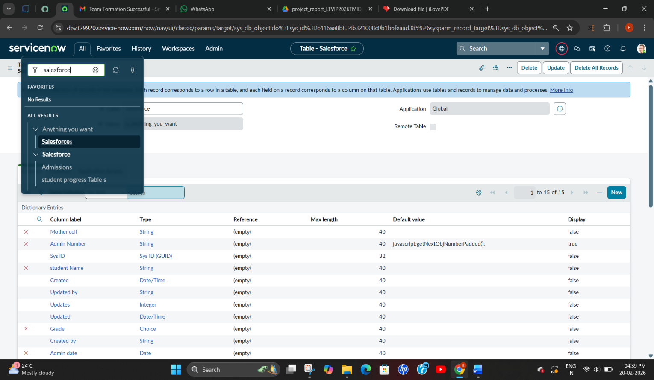

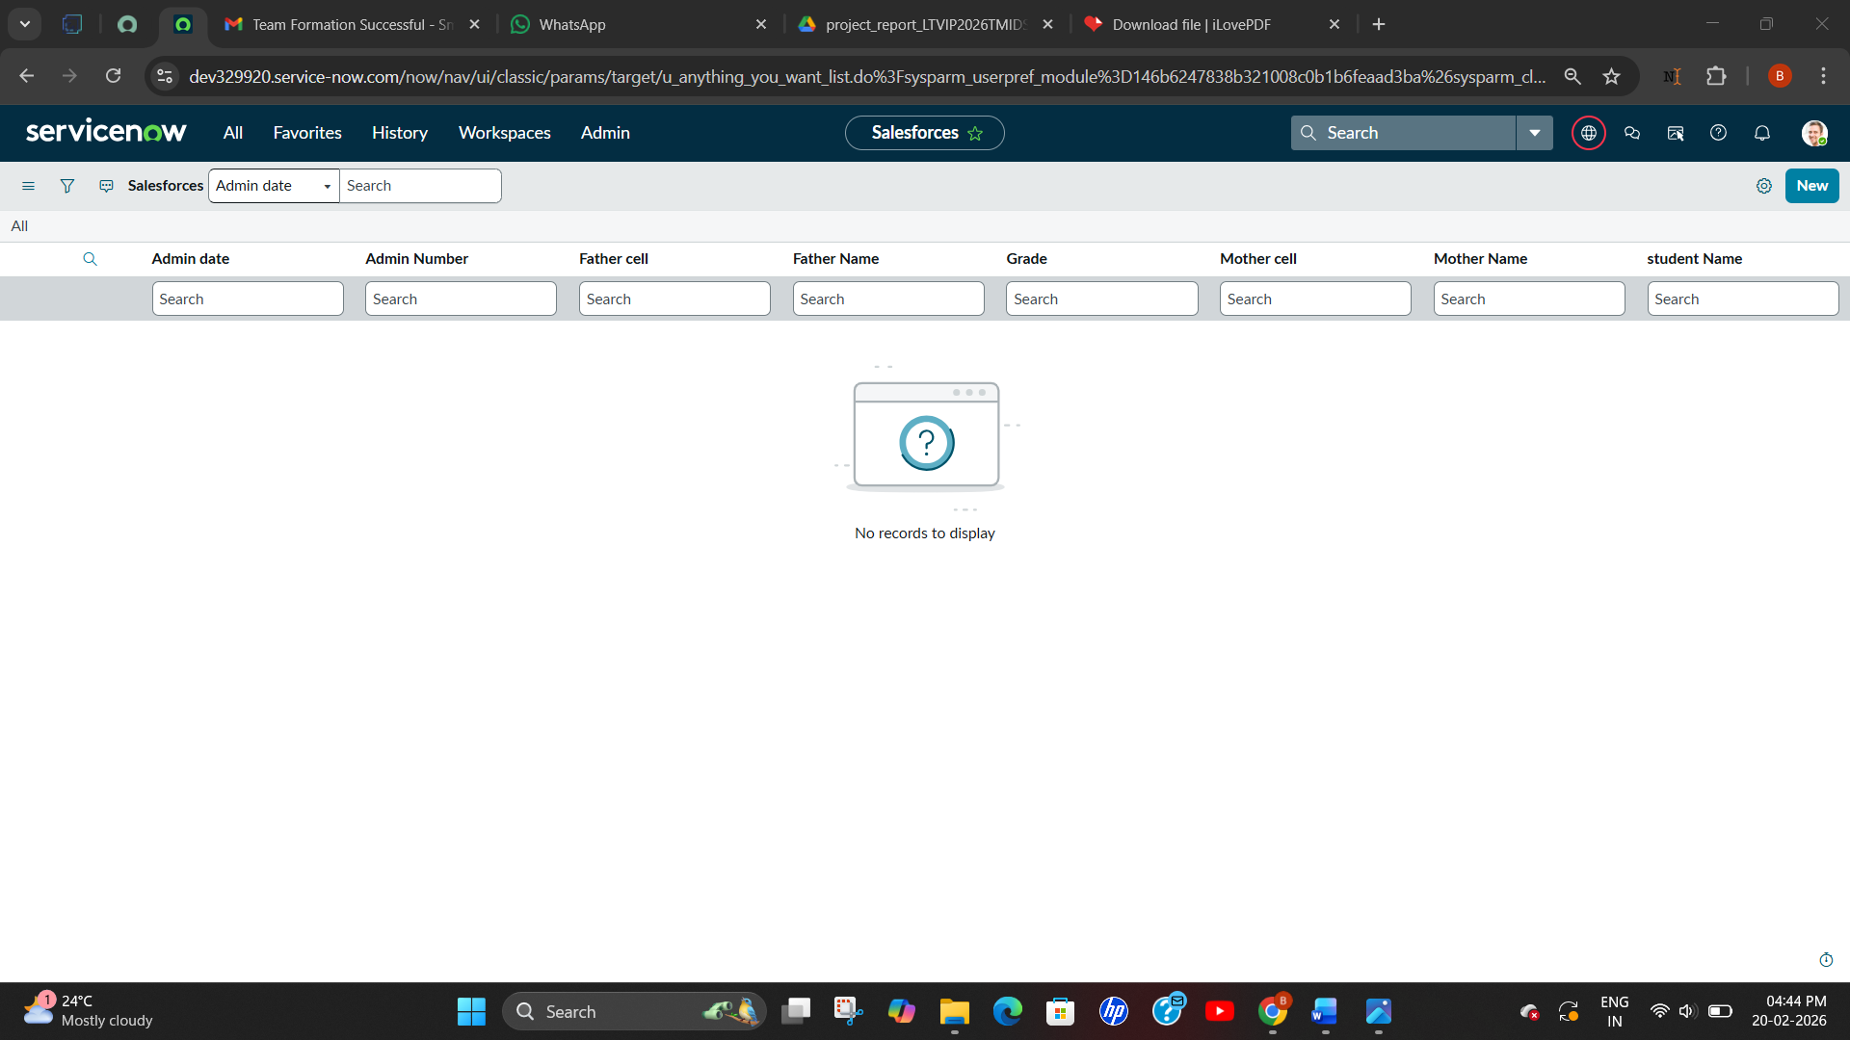

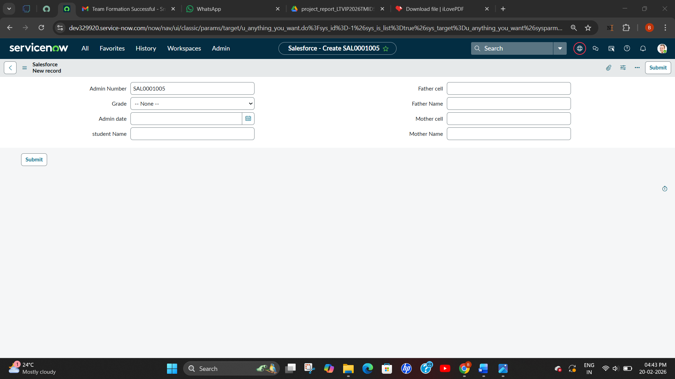

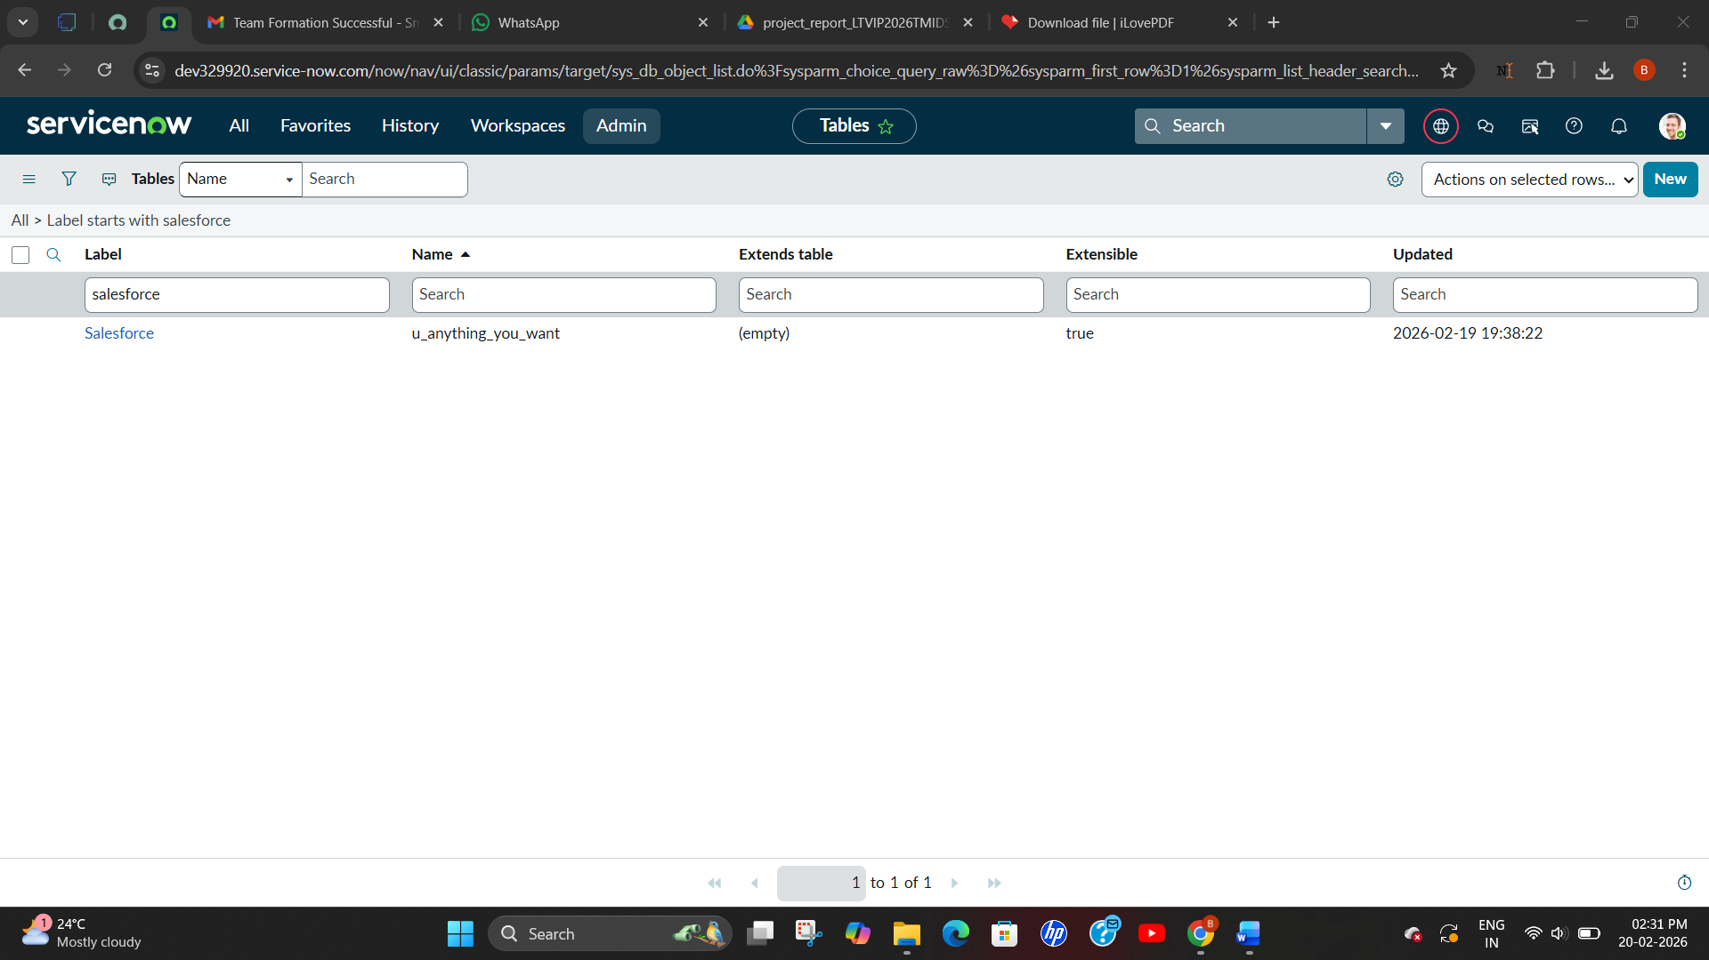

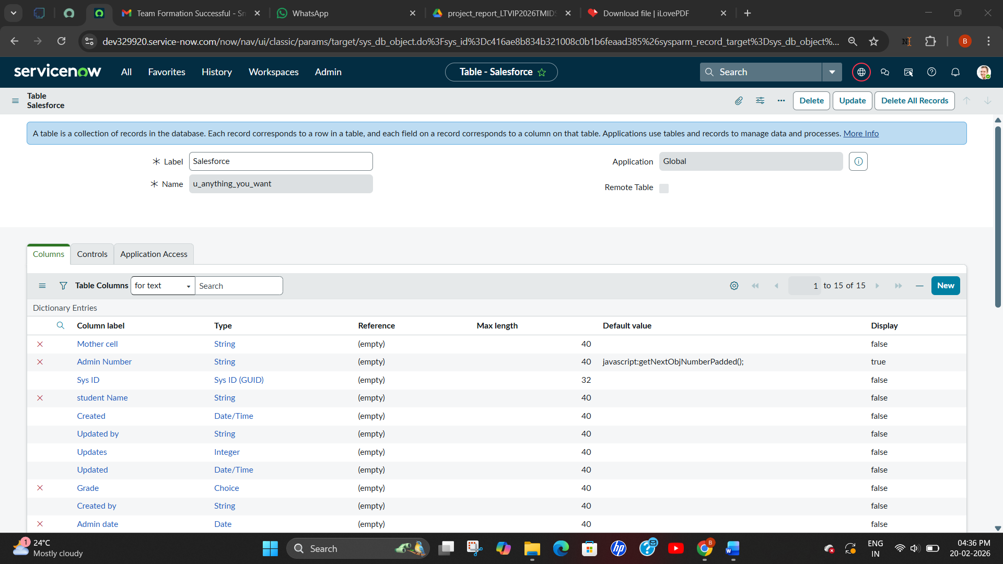

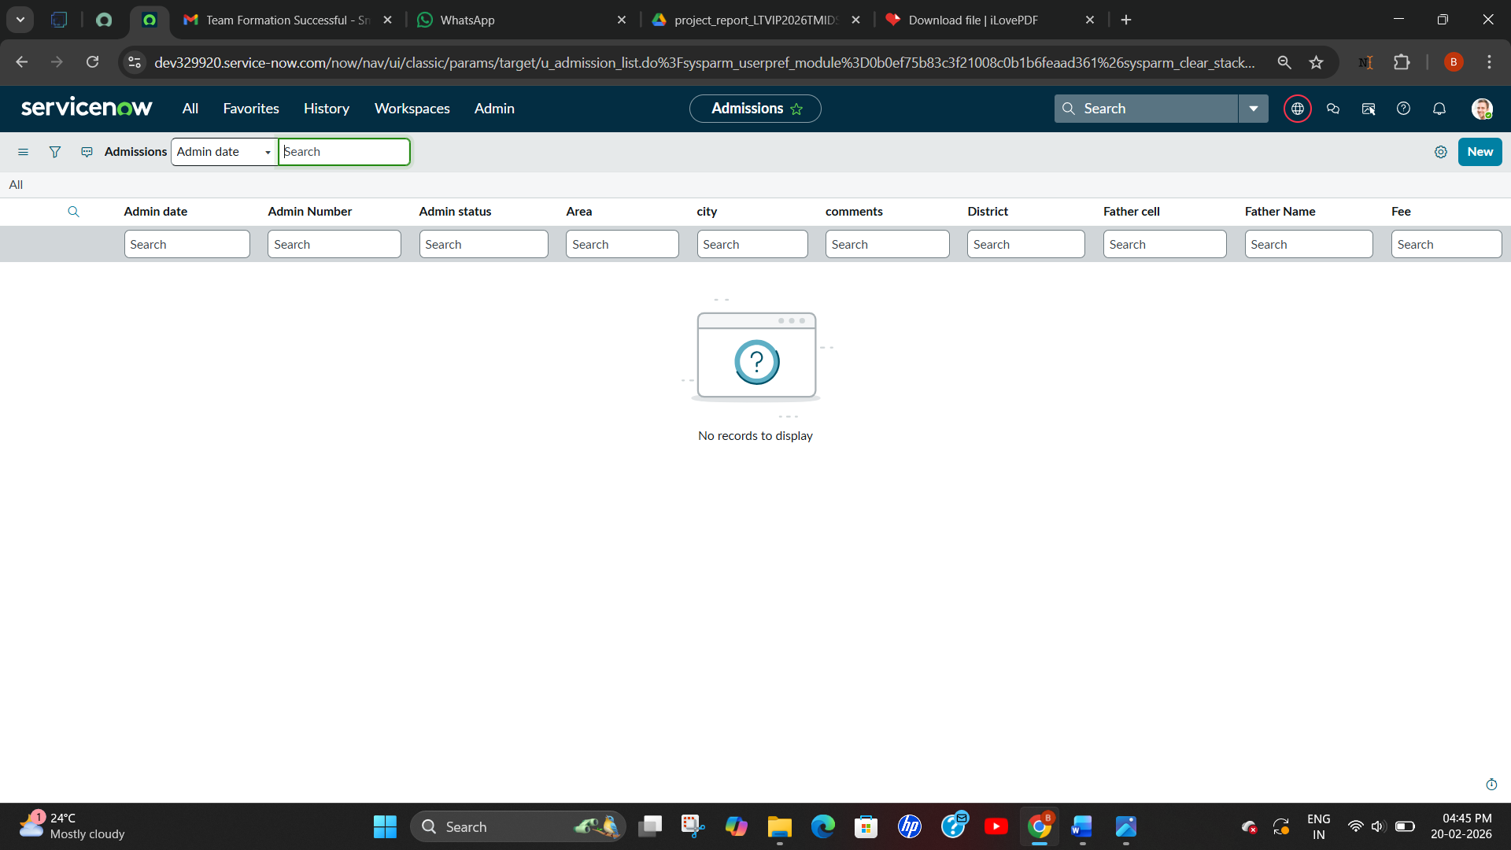

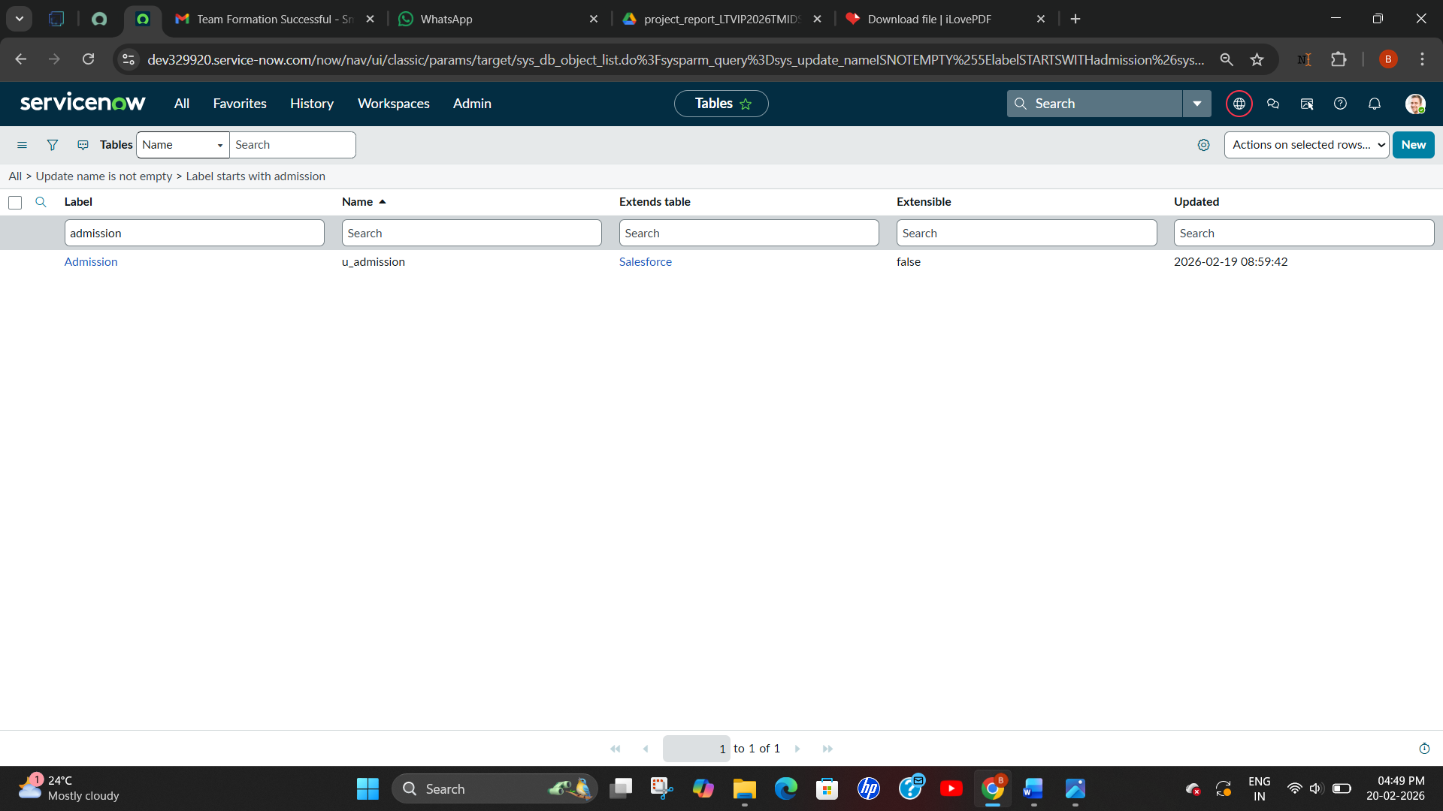

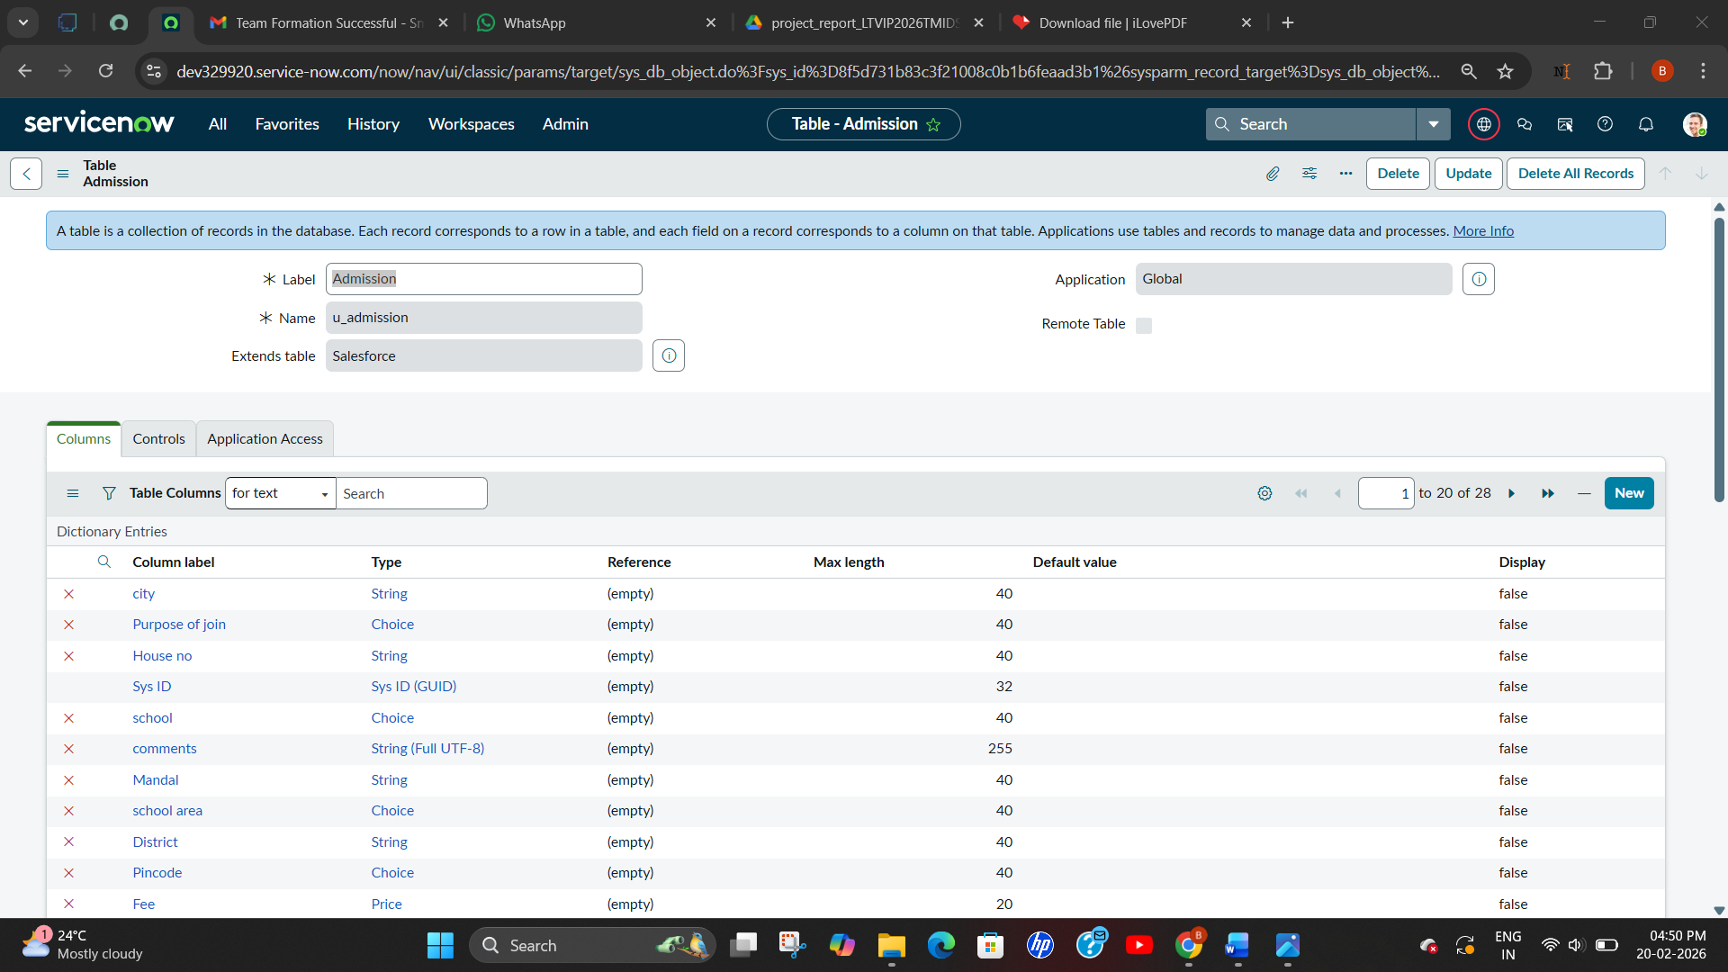

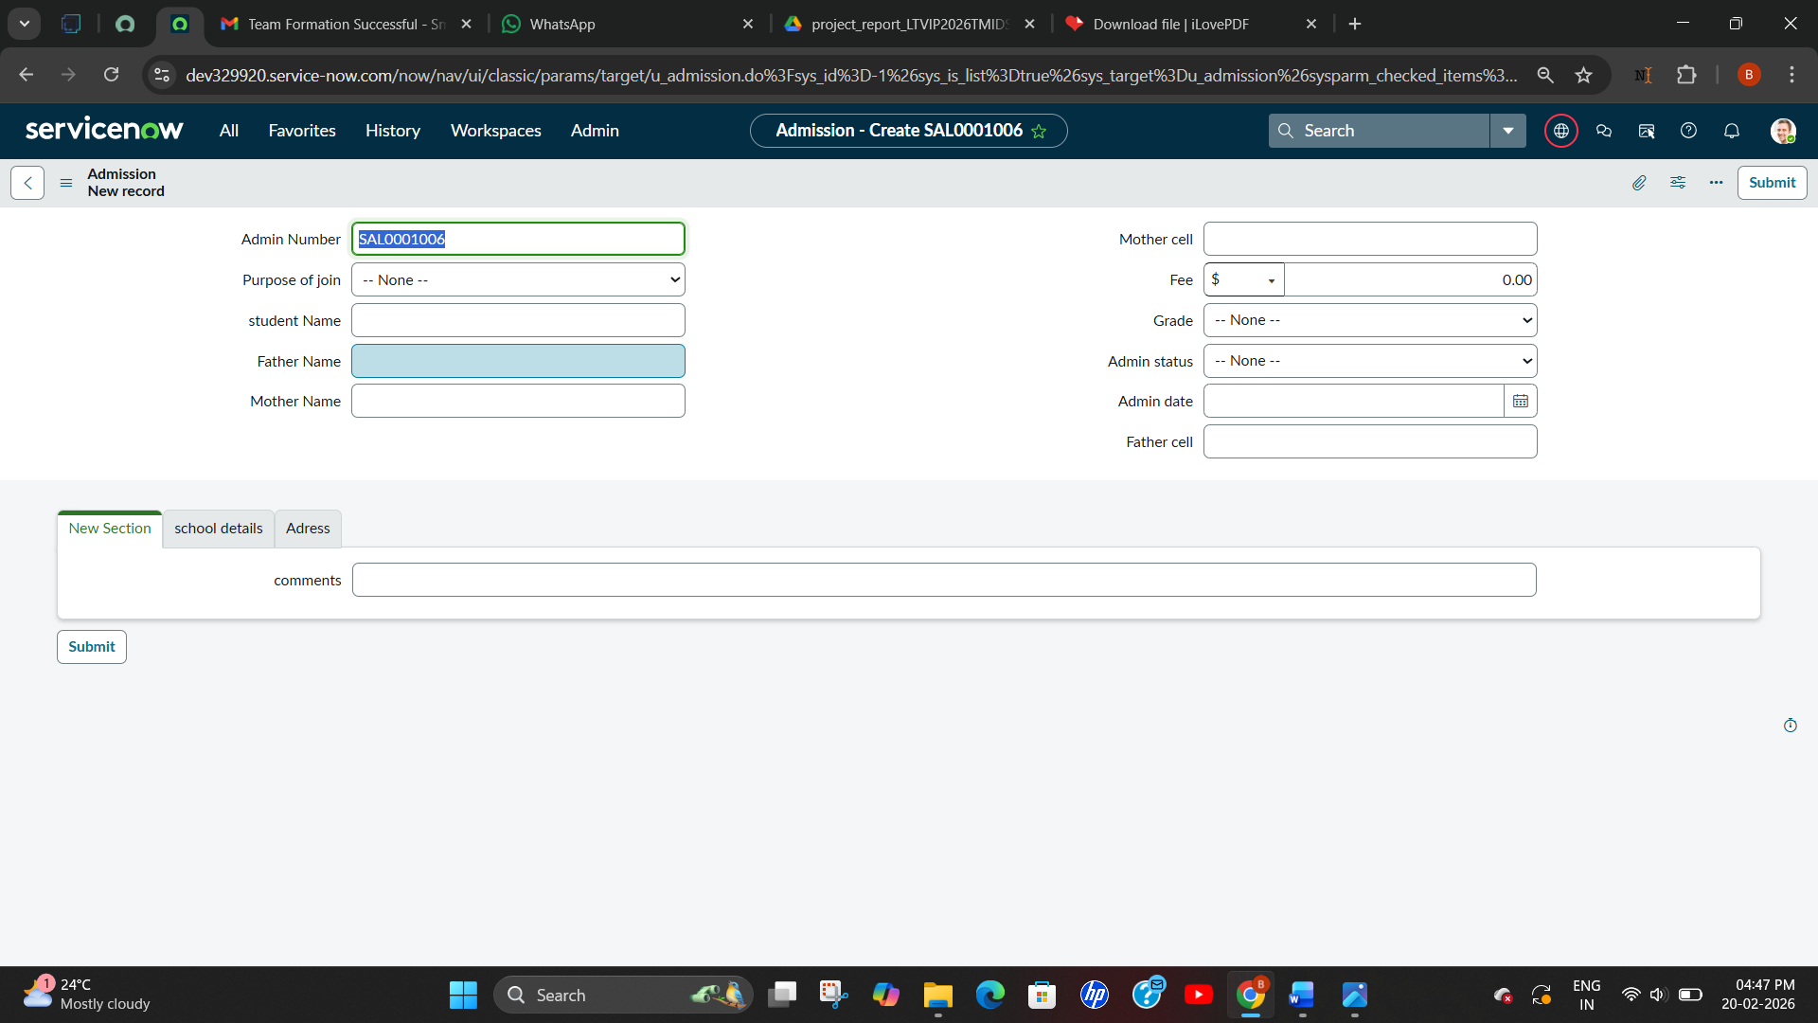

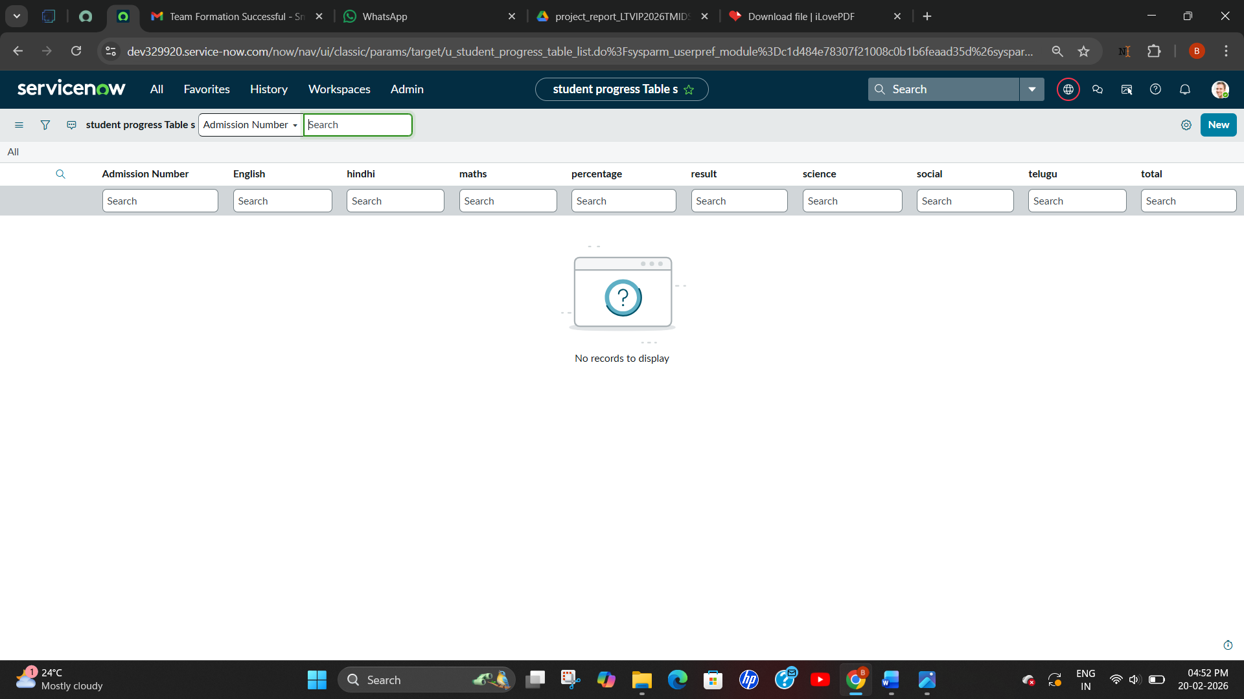

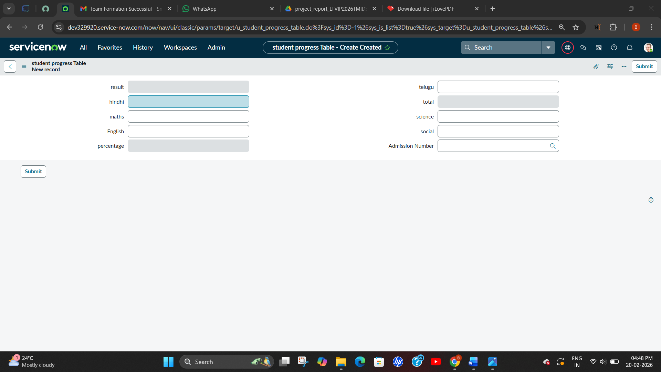

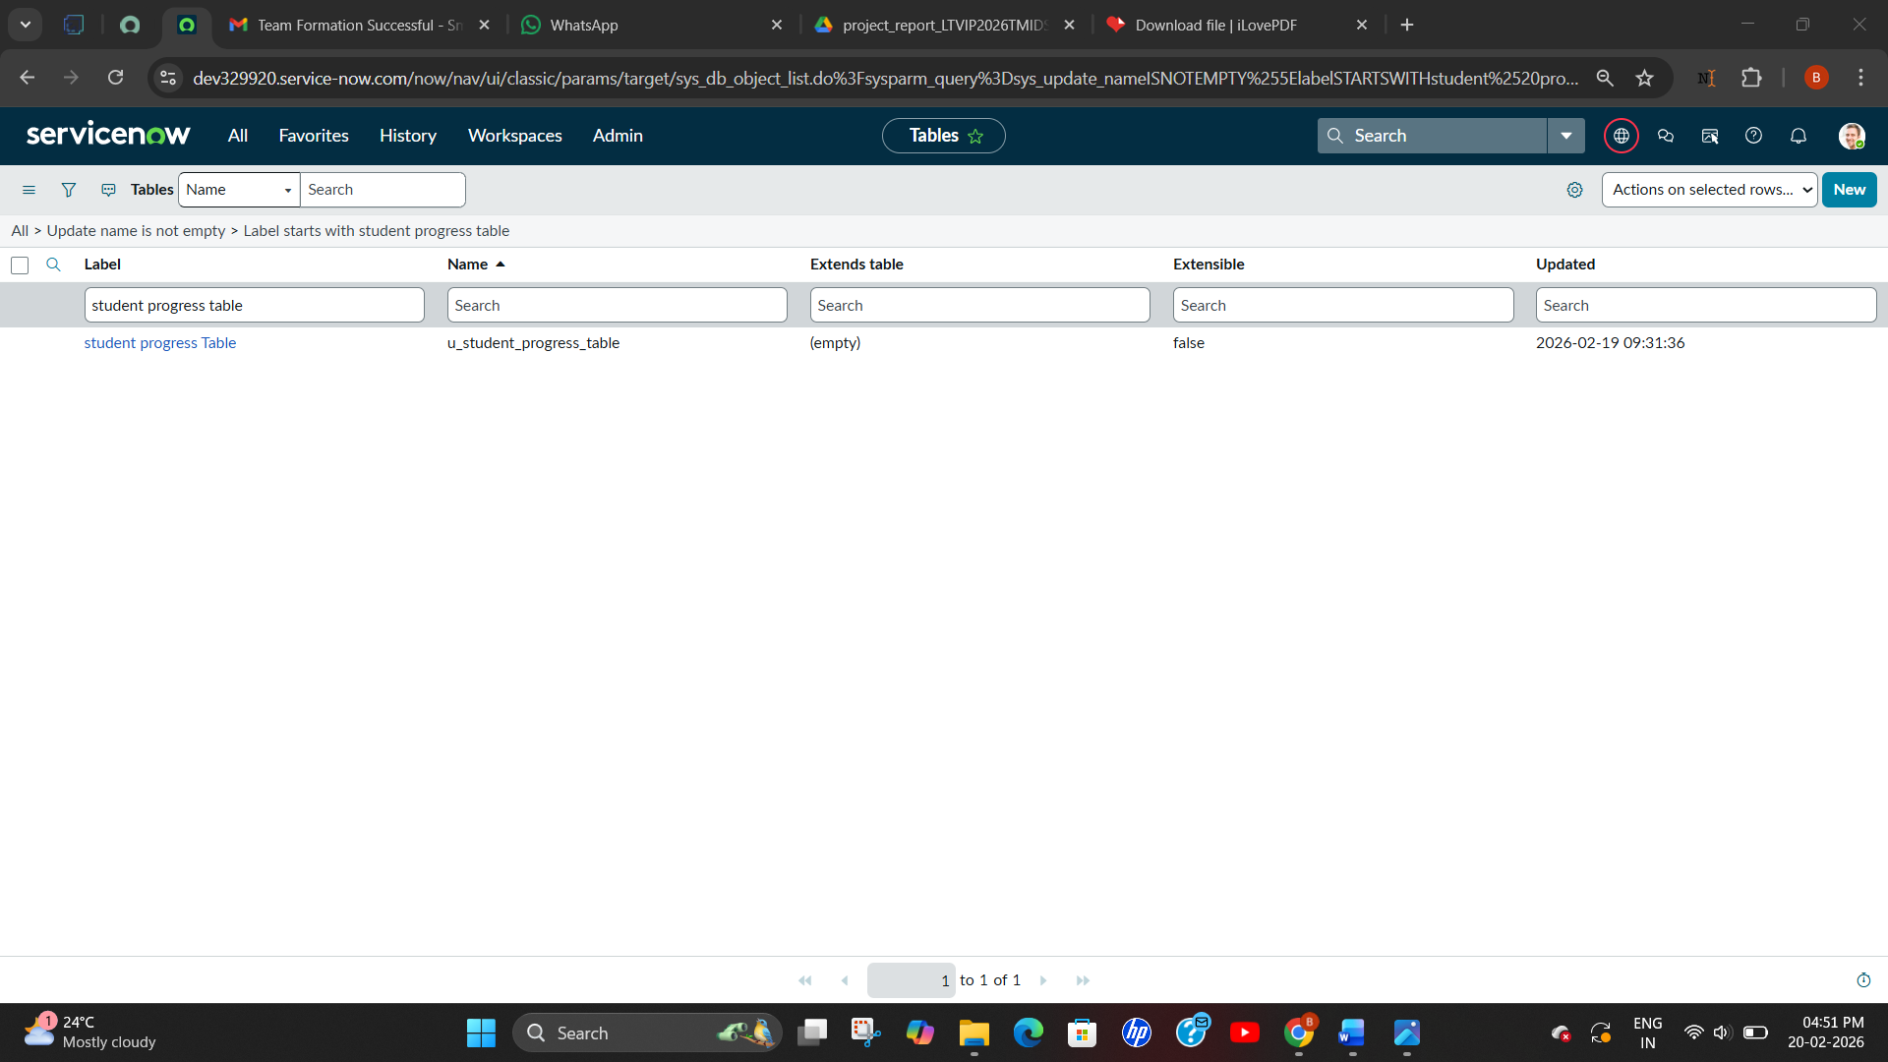

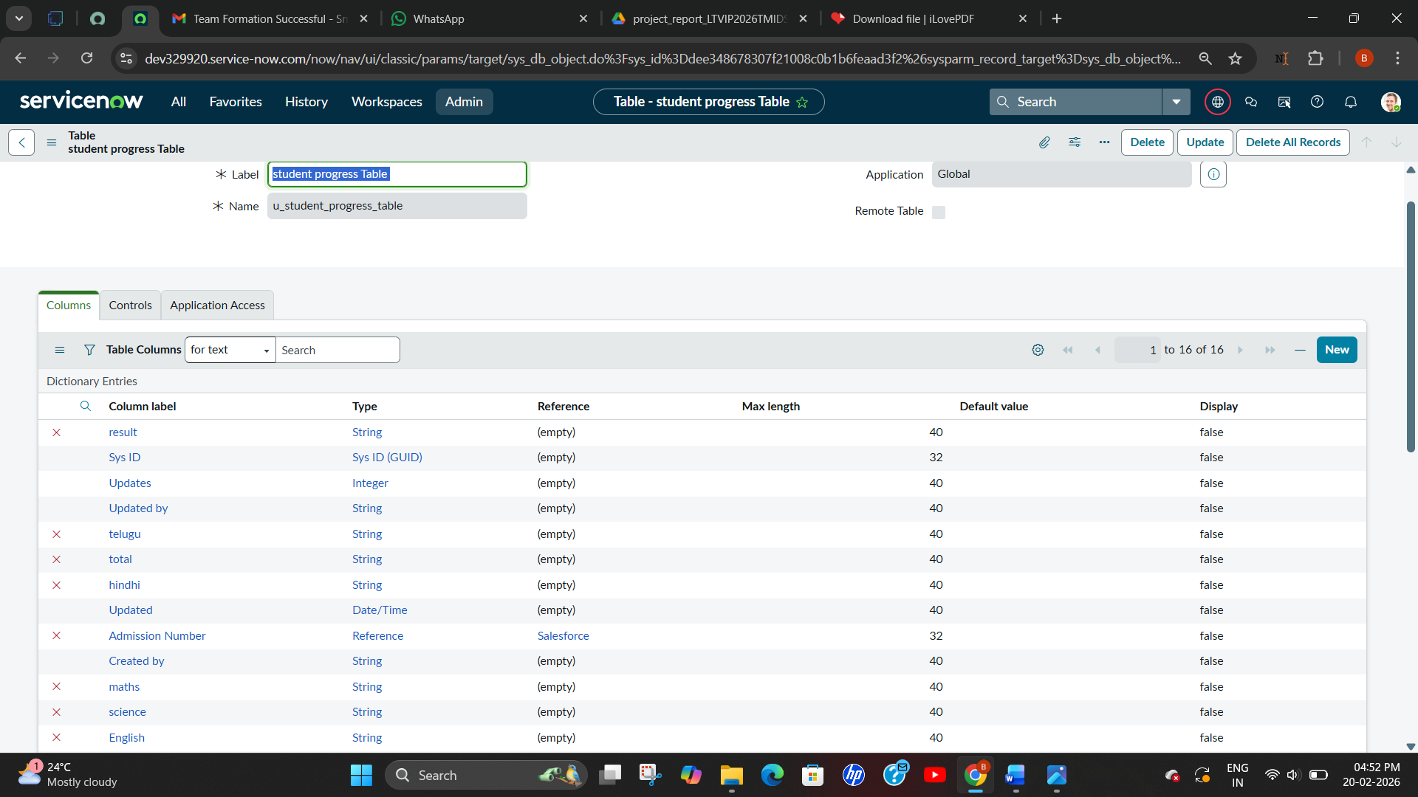

8. ADVANTAGES & DISADVANTAGES

Advantages
- Centralized system for managing educational services.
- Faster processing of student requests.
- Improved communication.
- Reduced manual work.
- Better tracking and transparency.
- Automated workflows increase efficiency.

Disadvantages
- Initial setup requires time and configuration.
- Requires knowledge of ServiceNow.
- Internet connectivity is necessary.

9. CONCLUSION
The Educational Organisation Using ServiceNow project successfully demonstrates how modern technology can improve the efficiency of educational institutions. By implementing a centralized platform, the system simplifies the management of student services and administrative tasks.
The project highlights the importance of automation in improving communication, reducing manual workload, and enhancing overall productivity. With the help of ServiceNow, institutions can provide better services and ensure a more organized workflow..

10. FUTURE SCOPE
The system can be further improved by adding advanced features such as:
- Mobile application integration.
- Artificial intelligence for request prioritization.
- Advanced analytics and reporting.
- Integration with existing student management systems.
- Automated chatbot support for students.

11. APPENDIX

GitHub & Project Demo Link

Github link :https://github.com/Tatineni-Bhavya/education-_organization_using_service_now_LTVIP2026TMIDS24889.git
Demo link : https://drive.google.com/file/d/1m0_CDp6e4aH26iQtaSNR2ggismJ_JQ8f/view?usp=sharing

